# Step by step analysis – Power BI assignment

## Name:

Instruction: Load and open the .PBIX file that has the name “Stores Sales Report” in Power BI. Answer the questions below and when asked, insert a screenshot to also illustrate your answer.

1. **Go to the tab** - **This Year Sales by Chain**

There are a total of 104 stores, 10 of which are new. We have two chains, Fashions Direct and Lindseys. Fashions Direct stores are larger, on average, than the Lindseys stores.

Go to the pie chart, and select Fashions Direct**.** Notice the result in the Total Sales Variance % bubble chart.

Answer the following questions and include a screenshot below this for your answers:

1. Which district has the highest average sales per square foot?

**Answer:** District FD-03 has highest average sales per square foot. The sales per square foot is $12.68 which is greater than other districts.

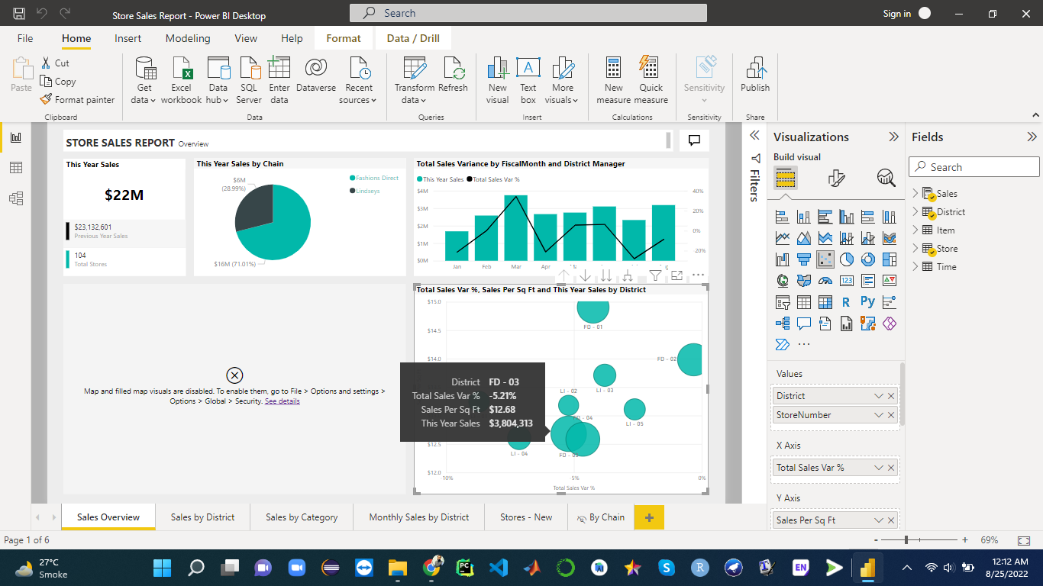

1. Which has the lowest overall sales variance compared to last year?

**Answer:** District LI-01 has lowest overall sales variance and which is -8.1 that means unfavourable.

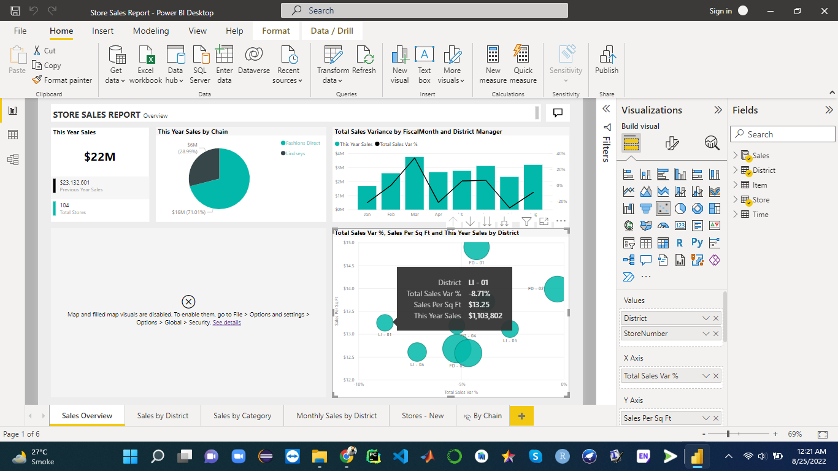

1. Which two of these districts are the worst performing overall?

Answer: There are two districts have worst performance as compare to other are LI-01 and LI-02.

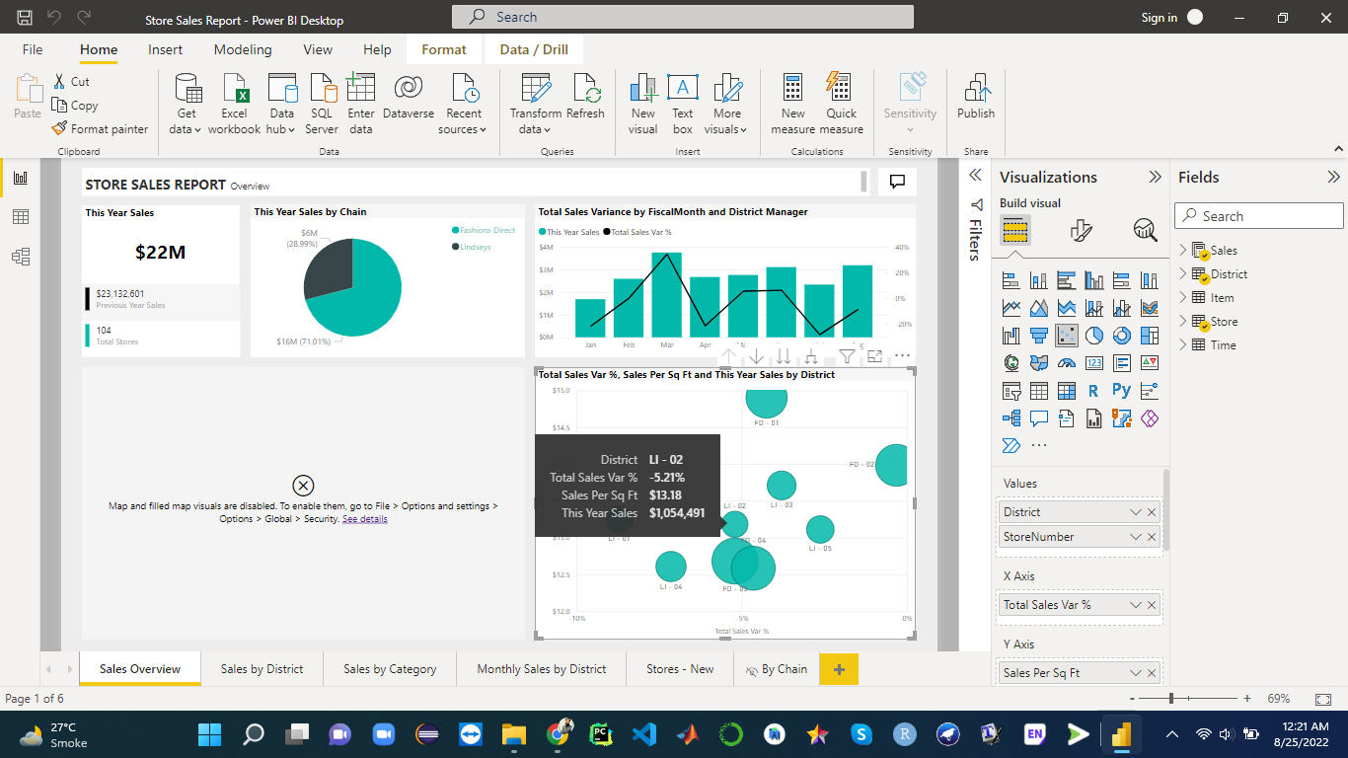

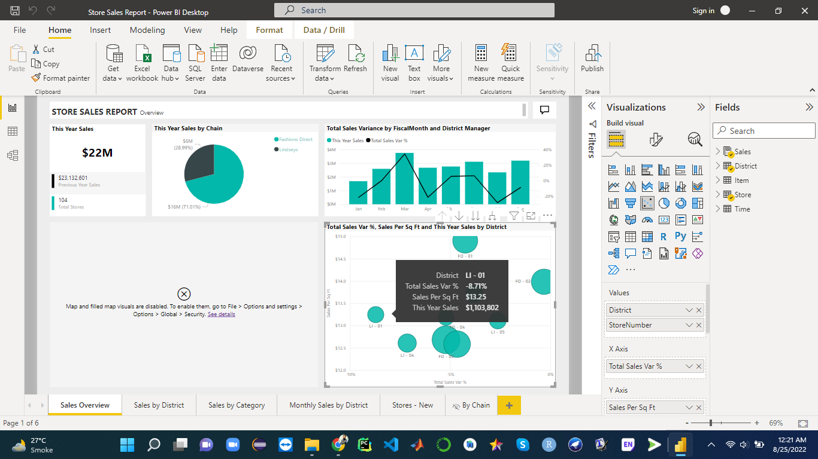

1. **Go to the Tab – Monthly Sales by District**
2. What has happened here this year? What was the worst month in terms of sales? Do we know why? Suggest reason(s) why that month is the worst.

Answer: Sales goes down from April towards the August. The sales variance was changes fast between the months as we can see July was the worst month in term of sales. Total sales variance in this month was -27.99% which was not good as compare to other months.

Reason(s): This year sales were lower than the last year in July that is one reason. Also the variance in this month was -27.99% which was not in favour of this month sales. Due to big difference in the last year sales and this year sales that become worst in favour of sales. If this year sale can improve that will be better in sales.

1. Do a drill down on the category 010 Women’s Fashion.

What has happened here? Explain with some analysis and a screenshot.

Answer: In the category of 010 Women’s Fashion the variance has great change as it was -33.30% which is big difference as compare to other others. The analysis based on the variance values and it is gretaer negative values which is unfavourable as compare to others. There was another major reason the sales in this year was low as compare to the last year for this category. See the second screenshot for low sales.

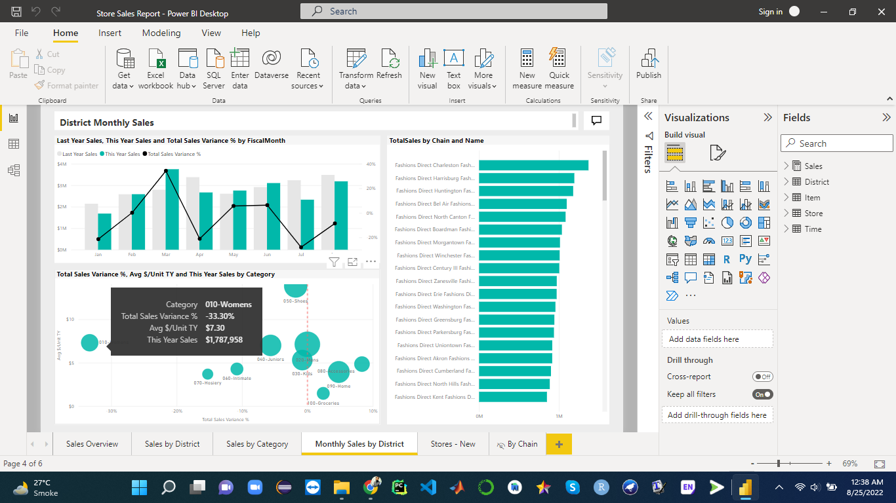

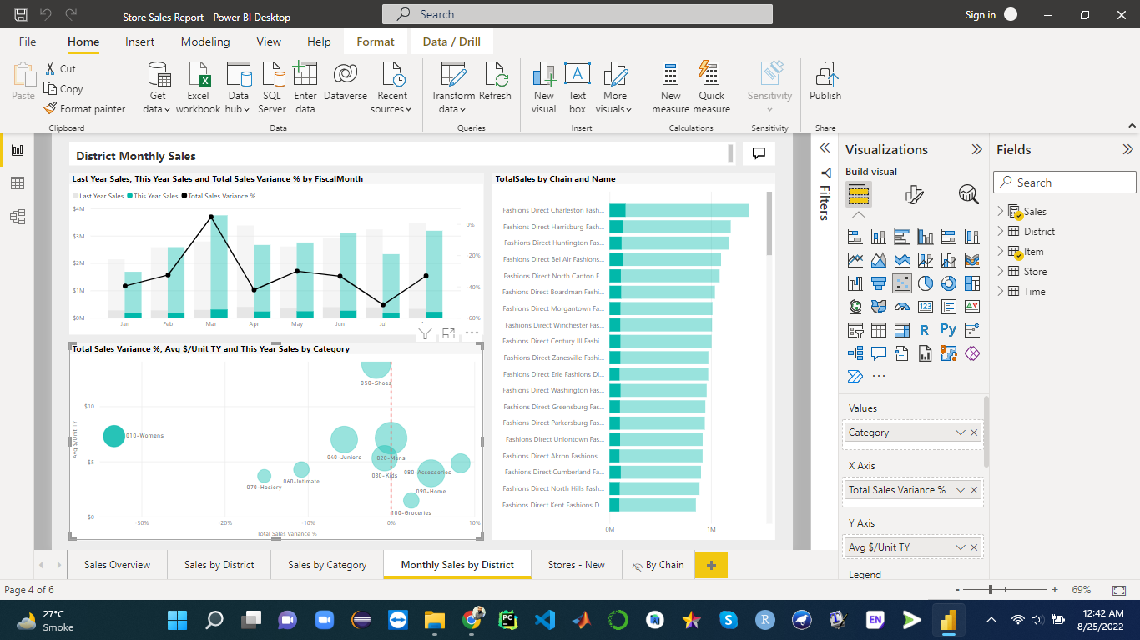

1. **Go to the Tab – Sales by District**

Start with the barchart with Sales by District. Add a Smart Narrative to the page below the bar chart and show via screenshot.

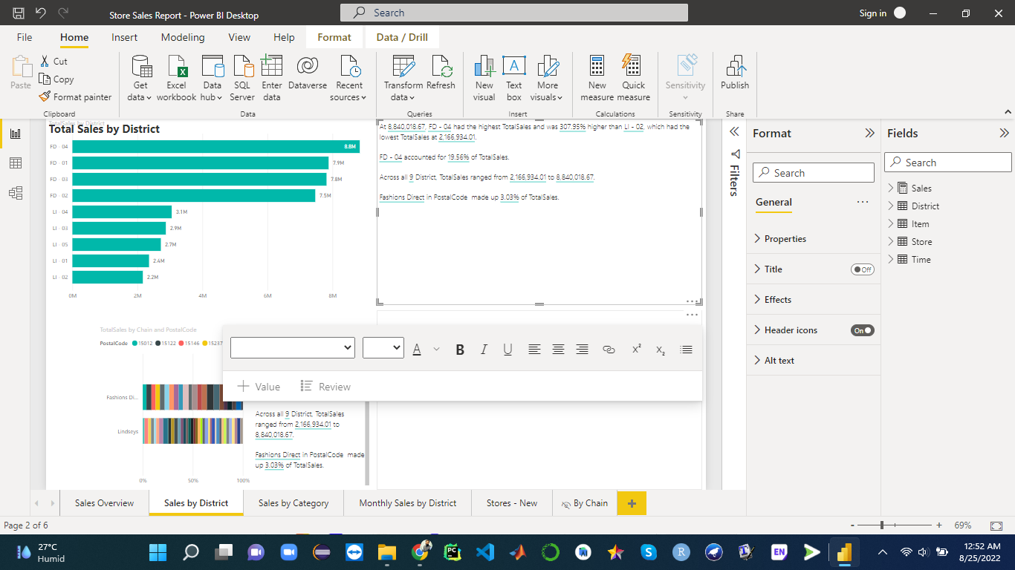

What is the range of total sales across the nine districts?

**Answer:** The range of total sales across the nine districts is Range = 8.8M -2.2M = 6.6M Because the min value of sale is 2.2M for the LI-01 and max sales value of FD-04 which is 8.8M

Then remove the smart analysis and add a tile to address the following constraint with a stacked bar chart: *this year's sales* ***by zip and chain***. Add a smart narrative, take a screenshot and tell us which zip code had the highest sales this year.

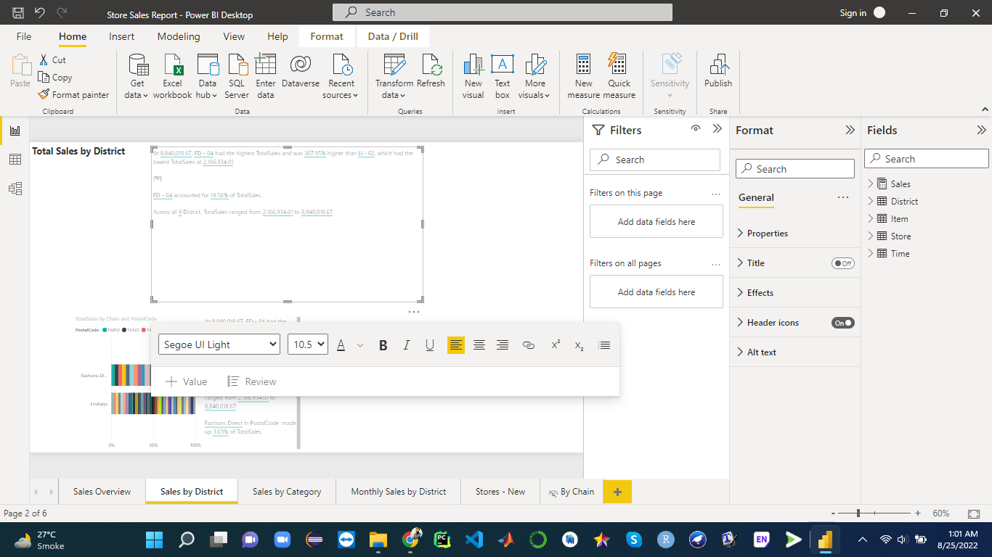

Zip code Answer: At 8,840,018.67, FD - 04 had the highest TotalSales

1. ﻿**Go to the Tab – Stores – New**

Sales took a hit over the summer months, particularly in July. See the sales variance by sales person from this year to last year. Which sales person had the strongest negative variance from last year’s sales in July? Any reason for this from what you can see?

Answer: Buchnan Alma has strongest negative variance with -40% variance values. Which is higher than other sales persons. Because in summer the month of july was lowest sales as compare to other months, second problem was the start of the sales was late.

**Part 2 - Creating a dashboard**

Attached you can find an Excel document containing multiple sheets. This represents the database of a university, it contains data on classes, students, professors, and grades. You have to create a dashboard that allows the dean of your program to gain valuable insights from this data.

Take the following steps:

Load the data in Power BI. Make the needed changes to the data using Power Query Editor if deemed necessary, be sure to check the data types.

Create the correct relationships between the different tables. The automatic ones by Power BI might not be correct.

Create a visually appealing and functional dashboard that highlights certain metrics. Have at least these visualizations:

Graph of an average grade per year across all students with a slicer allowing to filter courses.

Bar chart with enrollments per course with a slicer allowing to filter on years.

Pie chart of the number of students divided into age groups.

List of the full name of professors with the minimum grade they have given out.

Map with the number of students per country, with the average grade as a tooltip.

Add additional visualizations if deemed they add value, this can give you extra points.

Add text boxes to your dashboard to explain which insights you can derive from your dashboard.